Support the
10th Annual

We Salute Our First Responders and Fallen Heroes at Our Decade Celebration … Thank you to “those who have put their own lives on the line to ensure our safety!!

June 2, 2019; Rain Date June 9, 2019
11:00 a.m. to 6:00 p.m.
Rose Tree Park, Media, PA
FREE ADMISSION FOR ALL!!!

Sponso r... Ad ver tise...

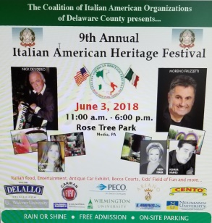
Platinum Package $2500
• Promotional table, with chairs and canopy at the Festival
• Banner placement at Rose Tree
Park (banner not provided)
• Front page logo in the official
Festival Guide
• Link to your website from
www.ciaodelco.org for 1 year
• FULL PAGE Festival Guide publicity
ad in high profile space plus radio
sponsor spot
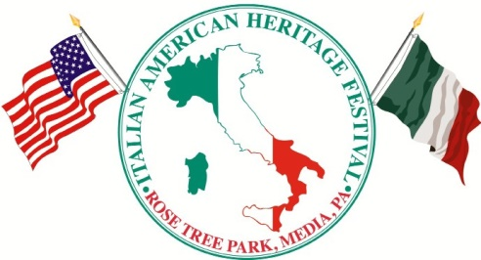

Yes, I would like to be a sponsor of the 10th Annual Italian American Heritage Festival!
- Platinum Package $2500
- Gold Package $1500
- Silver Package $1000
- Bronze Package $ 500
Selection: ______________________

I would like to place an ad in the 2019
Official Festival Guide!
Cost Ad Size
- Full Page $1000 9.89” x 8.75”
- Half Page $ 525 9.89” x 4.25”
- Quarter Page $ 325 4.89” x 4.25”
- Business Card $ 175 3.22” x 2”
Selection: _________________________

Return this order form and check payable to CIAO Delco by 4/19/2019 to CIAO Delco, P.O. Box 902, Brookhaven, PA 19015.

Gold Package $1500
• Promotional table, with chairs and canopy at the Festival
• Banner placement at Rose Tree
Park (banner not provided)
• Front page logo in the official
festival guide
• Link to your website from
www.ciaodelco.org for 1 year
• HALF PAGE Festival Guide publicity ad in high profile space

Silver Package $1000
• Promotional table, with chairs and canopy at the Festival
• Link to your website from
www.ciaodelco.org for 1 year
• QUARTER PAGE Festival Guide publicity ad

Bronze Package $500
• Promotional table, with chairs and canopy at the Festival
• Your business name on our website www.ciaodelco.org for 1 year
• BUSINESS CARD Festival Guide publicity ad

The Italian American Heritage Festival Guide is a multi-page insert full of information regarding vendors, entertainers, children’s activities and schedules distributed to the entire DelCoNews Network circulation, including the Delaware County Daily Times, and released the week prior to the Festival. The guide is also available on all tables at the Festival. Links to the publication are available on-line at both the CIAO Delco & DelCoNewsNetwork websites.

Festival produced by...
Coalition of Italian American Organizations of
Delaware County (CIAO Delco)

CIAO Delco Member Organizations: Associazione Regionale Abruzzese Delco, Nicholas Rapagnani, President
Associazione Regionale Abruzzese Delaware Valley, Gaetano Di Pasquale, President
Christopher Columbus Memorial Association, Joseph Stephano, President
Filitalia Delco,
Marguerite Faggioni-Miller
Justinian Society of Delaware County, Albert M. Greto, Esquire
Saint Anthony di Padova Society, SWP James Stigale, President
Società da Vinci
Ron Oronzio, Chairman
Sons and Daughters of Italy - District 5, Joseph Finio, 2nd State Vice President
Name: __________________________
Business Name: __________________
Address: ________________________
________________________________
Phone: _________________________
Email: __________________________
Amt. Enclosed: ___________________

Thank you for your support! Festival producers will contact you to follow up on promotional materials and festival arrangements.

Email your ad in .pdf format to ciaodelco@gmail.com
Mail form and check to:
CIAO Delco.
P.O. Box 902
Brookhaven, P A 19015

For more information:
Tracy Price Lochetto
(610) 405-0315
Dana Tarone Skahill
(610) 496-1716
Anita D’Alessandro
(610) 874-8773
ciaodelco.org facebook.com/ciaodelco

