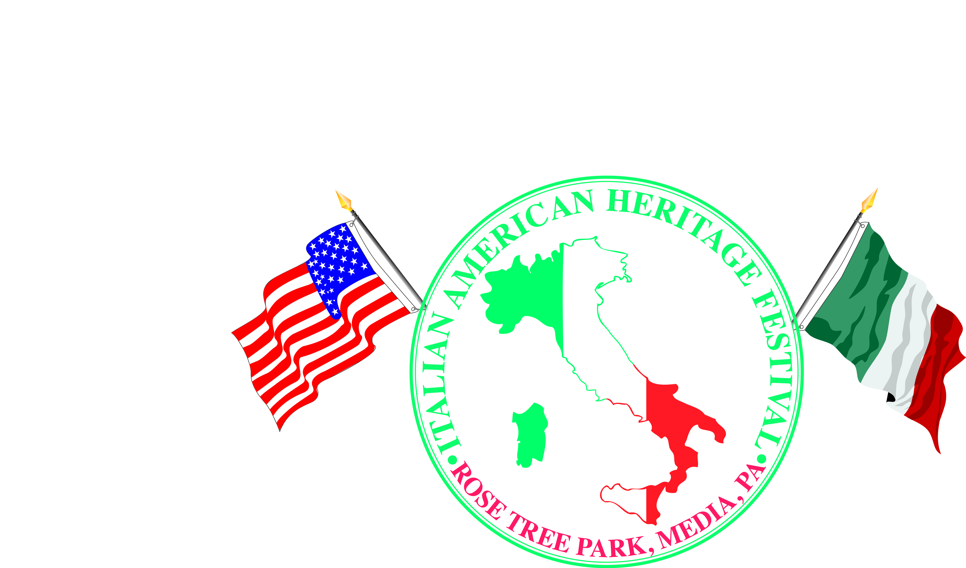

**CIAO Delco’s 9th Italian American Heritage Festival**

**Rose Tree Park; Sunday, June 3, 2018; 11:00 a.m. to 6:00 p.m.**

**Vendor Registration Form – Food, Sweet, Novelty**

**___________________________________ __________________________________**

**Business Name Contact Name**

**__________________________________________________________________________**

**Business Address**

**___________________________________ __________________________________**

**Email Address Phone**

* **FOOD 10x10 $400 20x20 $600**

**How many tables ($10 each) _____ and chairs ($2 each) _____ will you need?**

***\*Your business will be listed in our festival guide, in all promotional materials to the community, and find your business on the CIAO Delco website*** [***www.ciaodelco.org***](http://www.ciaodelco.org)

**\*List your Food selection… or, attach your proposed menu for the event.**

**If your menu conflicts with that of another vendor, we will request a modification. Early registration will have first preference on menu choices.**

**______________________________________________________________________________________________________________________________________________________**

* **SWEET 10x10 $200**

**\*Briefly describe your Sweet:**

**______________________________________________________________________________________________________________________________________________________**

* **NOVELTY/CRAFT/BUSINESS 10x10 $200**
* **NOVELTY/SPECIAL (Children) 10x10 $ 50**

**\*Package includes one 10x10 sales space at the Festival (secure racks and displays are acceptable); A table and 2 chairs (tablecloth not included, use red, white or green); One listing in the vendor section of the Official Festival Guide; Sponsor recognition and participation in press releases.**

**\*Briefly describe your Novelty (Special) Craft/Business:**

**______________________________________________________________________________________________________________________________________________________**

* **NON-PROFIT 10x10 $0**

**\*Package includes one 10x10 sales space at the Festival (secure racks and displays are acceptable); A table and 2 chairs (tablecloth not included, use red, white or green); One listing in the vendor section of the Official Festival Guide; Sponsor recognition and participation in press releases.**

**\*Briefly describe your Non-Profit:**

**______________________________________________________________________________________________________________________________________________________**

**Please complete and sign this Vendor Registration Form and if applicable, return it along with your non-refundable registration fee and a check made payable to CIAO Delco, P.O. Box 902, Brookhaven, PA 19015. Food & Sweet Only – Include a copy of your certificate of insurance naming The County of Delaware and CIAO Delco as additional insured.**

***I understand that the registration fee is not refundable. By signing this form, I agree to be bound by the rules set forth in the attached Vendor Agreement. Any vendor not adhering to these rules will not be eligible to return to the event.***

**___________________________________ __________________________________ Signature Date**